**North South University**

**Department of Electrical and Computer Engineering**

**CSE 215L: Programming Language II Lab**

**Lab** – **8: Composition, Inheritance**

**Objective:**

* To understand inheritance and its usage
* To to utilize inheritance to ensure reusability of existing code

Inheritance has two purposes - reuse existing code, reduce code duplication.

When common traits are found among two classes, define one as general/base/parent class and the other as specific/child class. Child class inherits the properties of parent class and adds its own properties.

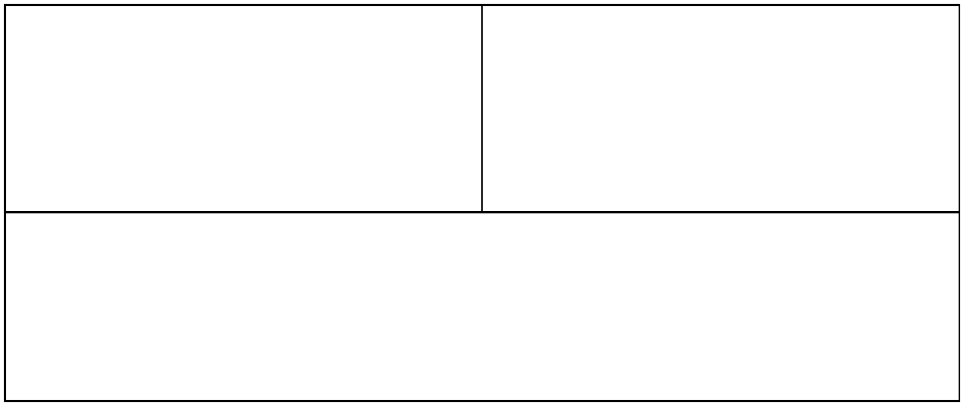

|  |  |
| --- | --- |
| class A{ | class B extends A{ |
| private String name; | private int value; |
| public A(String name){....} | public B(String name, int value){ |
| public String getName(){....} | super(name); |
| } | this.value = value; |
|  | } |
|  | public int getValue(){....} |
|  | } |

class Main{

public static void main (String [] args){ B b = new B("Thomas", 100); System.out.print(b.getName());

}

}

super( ) is used to call parent constructor to pass the attributes of parent class.

super keyword itself indicates parent object.

Java doesn’t support multiple inheritance.It supports multi level inheritance.

When child redefines a method from parent class, it’s called method overriding. Ex: toString( )

**Task:**

1. Implement the following classes and test toString() for each child object.

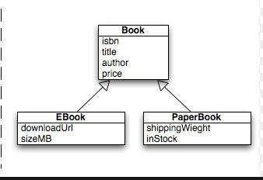

2. Implement the following classes. Then create a Square object and print its area and perimeter.

